**2023.4深圳2模 续写：从芭蕾到拳击**

**Version 1:**

*Then Kelly began her training for the tryout, keeping it a secret from her mom.* As usual, she continued attending ballet sessions, using the time to analyze the strength of dancers, applying the insights to boxing. To avoid **arousing suspicion of her mom**, Kelly told her she had joined an after-school study group, which explained her extra time away from home. Every day after school, she would slip into the empty dance studio, practicing her punches and footwork. In the evening, she would watch boxing videos on her phone, studying **defensive techniques and striking combinations**. Her heart raced each time her mom called or approached, fearful that her secret would be discovered. But Kelly remained steadfast, despite mastering boxing was more challenging than she anticipated. Anyhow, there was no regret as she tried her best.

*The following Monday, results of the boxing tryout were posted.* Anxious and **expectant**, Kelly approached the announcement board and scanned the list, surprised to find her name. Ecstatic, she rushed to share the news with Serena, who swept her sister into her arms, supportive of her determination in pursuing her passion. That evening, Kelly gathered the courage to tell her mom everything. At first, a sense of shock spread over her mom’s face as she learnt the truth. Yet seeing the commitment in Kelly’s eyes, mom gradually softened her expression into a bittersweet smile. “Compared with following the family tradition, your happiness was apparently more important,” mom beamed, **stroking her hair**. Deeply moved, Kelly hugged her mom tightly, grateful for her tolerance and hopeful for the boxer path she carved.

**Version2:**

*Then Kelly began her training for the tryout, keeping it a secret from her mom.* With her sister siding with her and helping make up an excuse for her coming home late, Kelly’s heart was injected with new energy. She went to the gym every day, observing carefully and training hard with other candidates, which proved that this was **not just her whim(心血来潮)**. Besides, the determined girl surfed the Internet, diving into the study of up-to-date contests as well as training strategies. The big day Kelly had been longing for arrived. Sparing no effort to move fast and hit hard on the stage, she exhibited her best self in the boxing ring, not in ballet.

*The following Monday, results of the boxing tryout were posted.* Nervousness seized Kelly when she stood in front of the poster. To her delight, she managed to be enrolled. So excited was she that she literally flew back to dancing club, telling Serena the good news. But what about mom? Her heart sunk. After a while, she decided to confess the whole story to mom. After all, this was the first time that she had made a big decision on her own. At first, mom was shocked and sort of angry, but after her calming down, she finally applauded her decision because this was her daughter’s own life, not others’. It was boxing that reshaped her new strength and carved her own path. Both of them came to understand that famous poem, “I am the master of my fate. I am the captain of my soul.”

Version3:

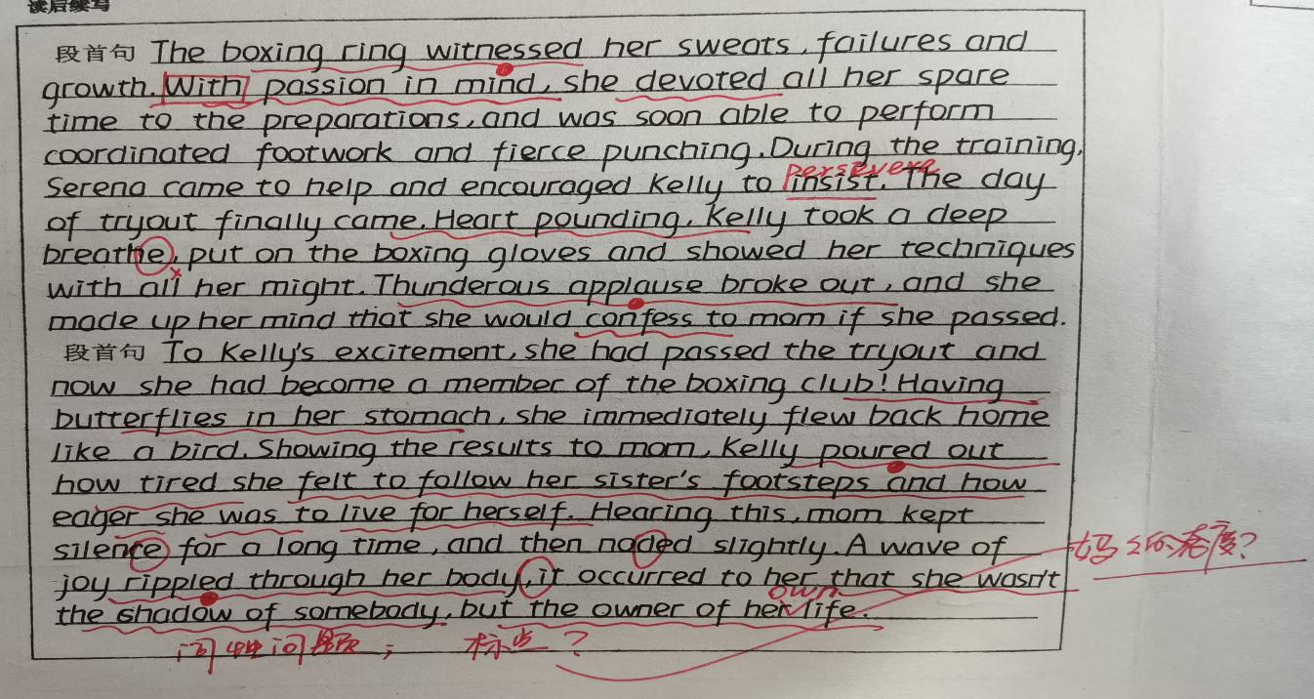

Ballet was a way of life in Kelly's family. Her elder sister Serena was now dancing at a top college. Though Kelly's mom always wanted her to follow in her sister's footsteps and Kelly herself was good at ballet, her love for ballet had faded years before, and she was eager for a new challenge.

One day at school, as Kelly left the dance studio, she walked past the gym, fascinated by boxers(拳击手)training inside the boxing ring. She was deeply impressed by how hard they hit and how fast they moved.In fact, she'd long been attracted to boxing.

She pulled a piece of paper from her backpack. On the familiar Oakwood High School Club Sign-up Sheet was the phrase: BOXING CLUB TRYOUT(选拔). That was what Kelly really wanted to do.She knew her mom had high expectations for her when it came to ballet. Tired of trying to keep up with her sister, Kelly was ready to carve her own path.

The next day, she gathered her courage and told Serena about her new passion. At first, Serena didn't understand and thought she was just joking. But when she saw Kelly was serious, she replied,“You know Mom wants you to be a ballet dancer, right? Besides, boxing is only for boys, and you're so good at ballet. Lean into your strength, Kelly.”

“But this is where I want to put my strength,”Kelly insisted,“and what exactly does ‘only for boys' mean, anyway? Boxing is a sport for everyone!”

Gradually, touched by her determination and passion,Serena began to understand and support her. Kelly could feel it. Her sister was going to respect her decision, no matter what. But that was nothing compared to the preparations for the tryout, where she was required to show her footwork and punching ( 击 打 )abilities with other candidates.Boxing didn't come natural to Kelly, but she had made up her mind to stick with her choice.

注意：

1. 续写词数应为150左右；

2. 请按如下格式在答题卡的相应位置作答。

|  |
| --- |
| Then Kelly began her training for the tryout, keeping it a secret from her mom.  The following Monday,results of the boxing tryout were posted. |

Kelly trained for the boxing tryout in secret, while still attending ballet sessions. She used her time at ballet to analyze dancers' strength and apply it to her boxing. To avoid suspicion, she told her mom she was joining an after-school study group. Every day after school, Kelly practiced her punches and footwork in an empty dance studio, watched boxing videos in the evenings, and feared being caught by her mom. Despite the challenges, Kelly remained dedicated to mastering boxing. When results were posted, she found her name on the list and rushed to share the news with her supportive sister, Serena. That evening, Kelly mustered the courage to tell her mom everything, revealing her passion for boxing. Though initially surprised, her mom recognized Kelly's happiness as more important than family tradition and gave her daughter a bittersweet smile. Touched by her mom's tolerance, Kelly hugged her tightly, grateful and hopeful for her future as a boxer.